I. TABLE DESIGN
(Font size: 12, Font style: Times New Roman)
1) Table Name: tbl_students
Table Description: Stores all registered student details
Field Name | Data Type | Constraints | Description
_id | ObjectId | Primary Key | Unique user ID
name | String | Not Null | Student name
email | String | Not Null, Unique | Email address
department | String | Not Null | Department (BCA, etc.)
year | String | Not Null | Academic year
password | String | Not Null | User password
photo | String | Nullable | Profile image

2) Table Name: tbl_notes
Table Description: Stores uploaded academic notes
Field Name | Data Type | Constraints | Description
note_id | ObjectId | Primary Key | Unique note ID
title | String | Not Null | Note title
subject | String | Not Null | Subject name
file | String | Not Null | PDF file path
uploaded_by | ObjectId | Foreign Key (tbl_students) | Student ID
upload_date | Date | Not Null | Date of upload

3) Table Name: tbl_marketplace
Table Description: Stores book listings for buying/selling
Field Name | Data Type | Constraints | Description
book_id | ObjectId | Primary Key | Unique book ID
book_name | String | Not Null | Name of book
price | Number | Not Null | Book price
description | String | Nullable | Book details
seller_id | ObjectId | Foreign Key (tbl_students) | Seller ID
contact | String | Not Null | Seller contact info

4) Table Name: tbl_chat
Table Description: Stores chat messages
Field Name | Data Type | Constraints | Description
message_id | ObjectId | Primary Key | Unique message ID
sender_id | ObjectId | Foreign Key (tbl_students) | Sender
message | String | Not Null | Message content
timestamp | Date | Not Null | Time of message

5) Table Name: tbl_login
Table Description: Stores dashboard-related data (optional)
Field Name | Data Type | Constraints | Description
login_id | INT | Primary Key, Auto Increment | Unique login ID
email | Varchar | Not null, unique | User email
Password | Varchar | Null null | User pass
Role | Varchar | Not null | User role(student admin
Status | Varchar | Not null | Account status

II. DATA FLOW DIAGRAM (DFD)
(Yourdon and Coad Notation dfd)
Notation Reference:
Rectangle = Source / Destination (External Entity), Circle = Process
Open Rectangle (parallel lines) = Data Store, Arrow = Data Flow
Context Level DFD (Overview of System)
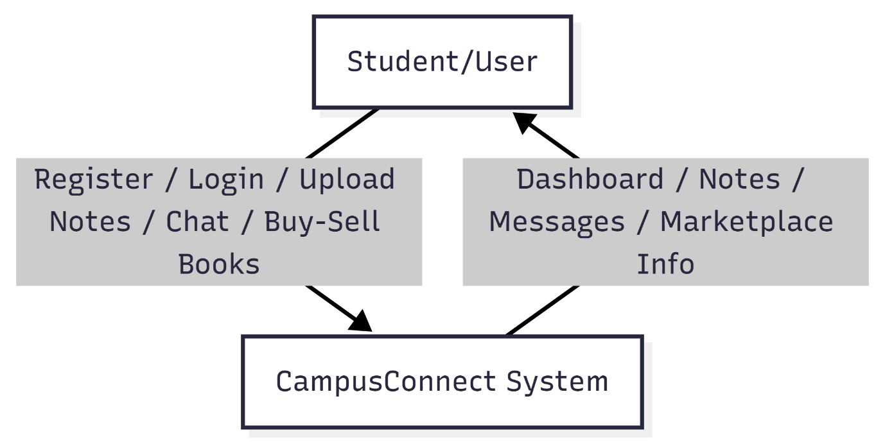
This diagram shows the overall view of the system. It explains how the system interacts with users like Admin and Students. The system is shown as one process, focusing only on input and output of data. This diagram helps to understand what the system does as a whole without going into internal details.

Level 0 DFD (Main Functions of System)
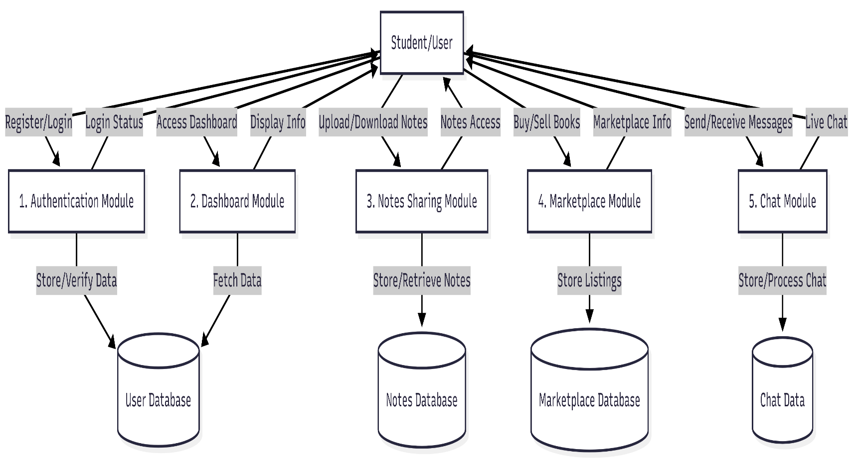

This diagram shows the main parts of the system. It includes processes like managing users, subjects, questions, and generating papers. It also shows how data moves between these processes and data storage. This level helps to understand how the system functions internally at a basic level.

Level 1 DFD (Detailed View of Process)
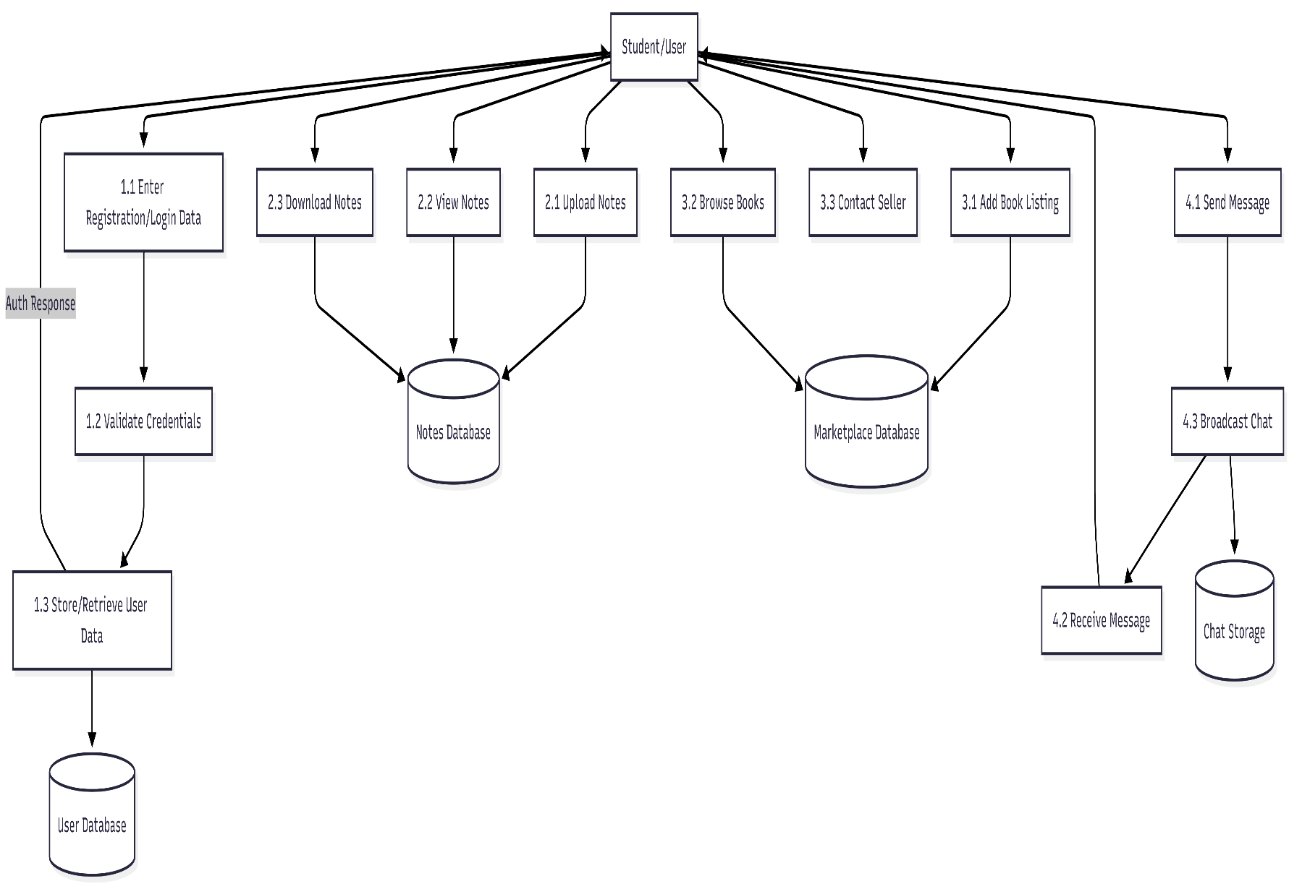

This diagram shows a detailed step-by-step flow of a specific process. It explains how data is handled inside the system, like adding questions and generating question papers. This level helps to understand the step-by-step flow of data within a specific part of the system, making the logic much clearer.

